Brussels, 7 May 2021

Re: Invitation to join the ICATOR class action

Dear Cybertorture Victim,

As President of the ICATOR, I have been focussing during the recent months on finding a suitable European attorney to start a class action lawsuit.

I am pleased to announce that this lawyer has been found.

Indeed, we were able to secure legal representation with one of the tenors of the Brussels Bar.

This morning, the ICATOR board met with him.

We are delighted to inform you that every cybertorture victim (commonly called “targeted individual” or “TI”) on the globe may be eligible to join the ICATOR class action as a plaintiff.

The two main objectives of this lawsuit are:

- Forcing legislation to regulate the trade of nanotechnology- and psychotronic weapons in Europe
- Obtaining compensation for all cybertorture victims, members of ICATOR

Every victim, who joins ICATOR as a member (Annual membership fee of 60 €as a regular member or 120 € as a supporting member) can be a registered as a plaintiff entitled to compensation by the EU.

To be able to obtain compensation of our members also outside the EU, we will thus register you as a temporary EU resident with our lawyer’s office. This registration is an administrative formality only effective for the duration of the court case.

To simplify the submission of evidence, we will provide you with a standard affidavit template to fill out.

The attorney’s retainer fee of 10.000 -15.000 € is to be raised as of now.

This fee is for the realization of a legal expertise pertaining to all our evidence and will kick start the class action.

The legal expertise is the prerequisite of this lawsuit and represents the greatest costs.

In the course of the juridical process, there will be other fees for our representation at the European Court on Human Rights.

However, these costs will never exceed the initial retainer fee for the legal expertise.

The ordinary hourly rate of the law firm is fixed at 165 € / hour excluding VAT.

With the initial legal expertise, appointed court experts need to examine all our affidavits and available evidence for the trial.
If we win at the European level, the legal expertise and the court judgment in our favour may also be used in other countries and jurisdictions.

If you would like to take part in the lawsuit as our member and/or donate to our class action, please do so at the following link: https://icator.be/donate/

Thank you for your support!

Yours sincerely,

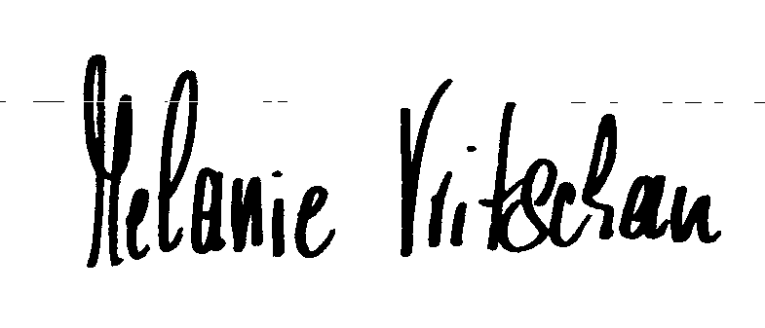

Melanie Vritschan
President of ICATOR

